## **Create a pull request to merge your changes into main**

Pull requests let you tell others about changes you've pushed to a branch in a repository on GitHub. Once a pull request is opened, you can discuss and review the potential changes with collaborators and add follow-up commits before your changes are merged into the base branch. Once the changes are agreed upon and the pull request is approved, your changes can be merged. For our purposes, we will not require approvals and merge our changes ourselves.  
  
You can read more about Pull Requests here: <https://docs.github.com/en/pull-requests/collaborating-with-pull-requests/proposing-changes-to-your-work-with-pull-requests/about-pull-requests>

In GitHub Desktop, select the exercise branch you want to merge into main. Once you have pushed your changes to the remote repository, you’ll see an option to “Create a Pull Request from your current branch”. You can also access this from the Branch menu or by pressing Ctrl + R.

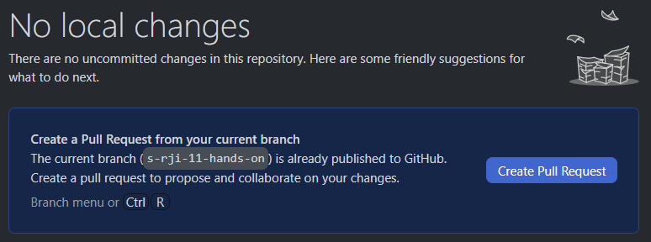

After you press the “Create Pull Request” button, you’ll be taken to the GitHub webpage.

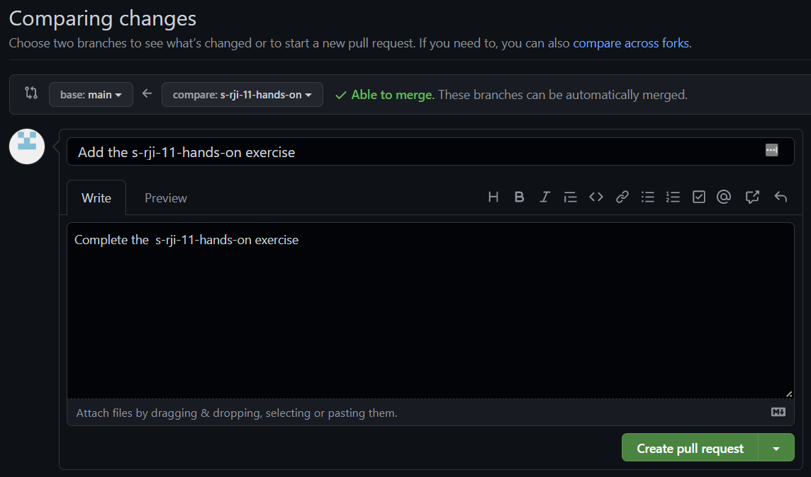

Here you have the option to edit your pull request and finally press “Create pull request”. Congratulations, your pull request is now open!

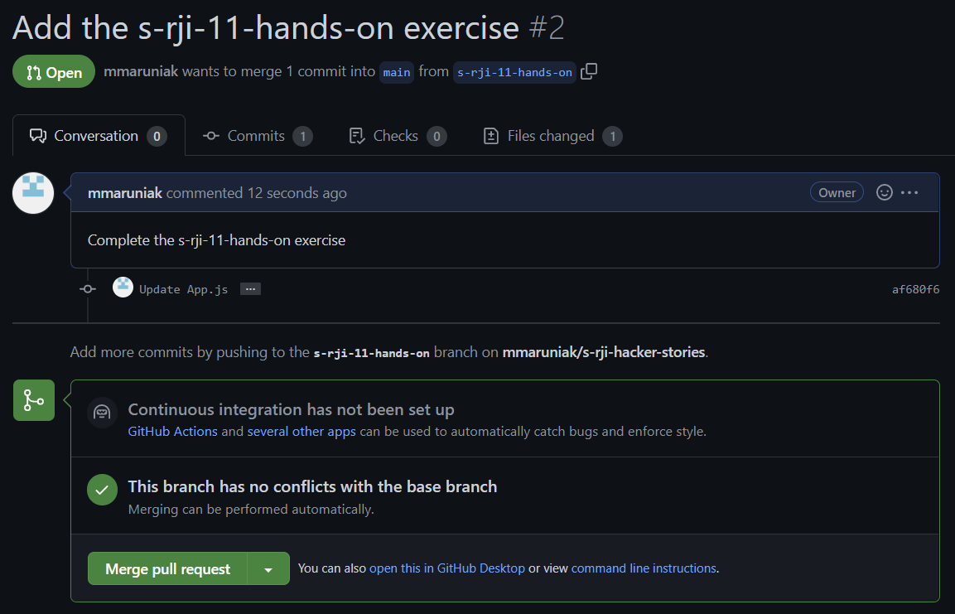

Finally, if you want to merge your changes into main, press “Merge pull request”. Otherwise, you can leave the pull request open.